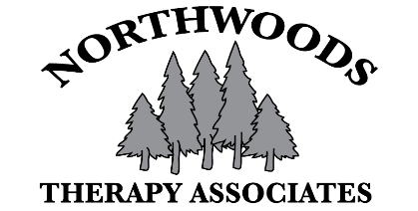

NORTHWOODS THERAPY TREATMENT OF MINOR CONSENT FORM
Patient Name:
DOB: | Age: | Gender:

CONSENT___________________________________________________________________
To comply with Wisconsin law, Northwoods Therapy requires that a parent (not step-parent/foster parent) or legal guardian (guardian appointed by a court) accompany any minor child (17 years old or younger) to their therapy appointments. In the event that a parent or legal guardian is unable to accompany his or her minor child to a medical treatment appointment, the parent or legal guardian must sign this consent form for treatment of minors.
Name of parent or legal guardian: ___________________________________________________________

Name of child: ___________________________________________________________________________

⃝ I consent to care and treatment for my child related to treatment of his/her _______________________ at Northwoods Therapy Associates.

If there is a need to reach me during my child’s appointment to discuss further care or treatment, I may be reached at the following phone numbers:

Home: (_______) __________- __________ Work: (_______)__________-__________

Cell: (________) __________-__________

I further agree to reimburse Northwoods Therapy for the cost of rendering these services to the extent that my insurance does not pay for these services:

______________________________________________________ ______________________________
Child’s parent or legal guardian signature Relationship

______________________________________________________ ______________________________
Print child’s parent or legal guardian name Date (month/day/year)

_______________________________________________________________________________________
Child’s parent or legal guardian address

